**Apache Kafka**

**Introduction :-**

When we have many source system and many target systems

Each integration comes with difficulties around:-

1.protocol- how data is transported(TCP,HTTP,REST,FTP,JDBC)

2.data format- How the data is parsed(binary,csv,json,avro)

3.data schema and evolution- how data is shaped and may change

Apache kafka decouples data streams and the system.

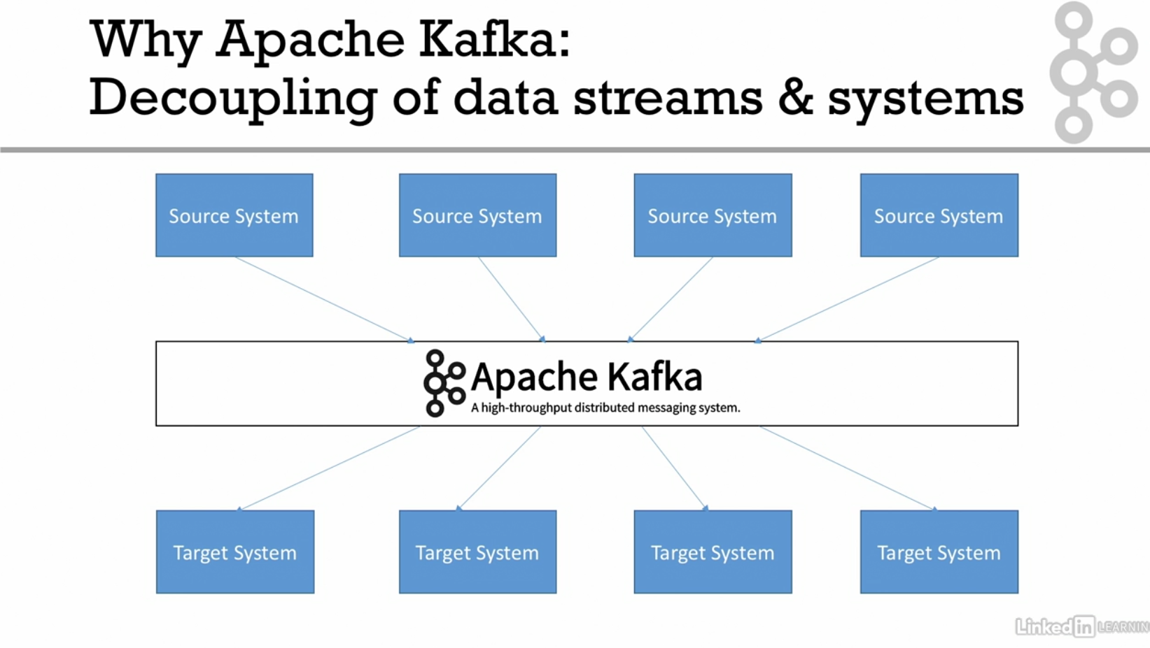

🡪created by linked in now and open source mainly maintained by confluent

🡪distributed , resilient architecture, fault tolerant

🡪horizontal scalability

🡪high performance

🡪used by 2000+ firms, 36% of fortune 500 like uber, Walmart etc

**Use cases**

🡪Messaging system

🡪Activity Tracking

🡪Gather metrics from many different locations

🡪Application logs gathering

🡪Stream processing

🡪Decoupling system dependencies

🡪Integration with spark, flink , storm , haddop and many other big data technologies

e.g

Netflix: recommendations

Uber: to gather user, taxi and trip data to calculate surge

Linkedin: to detect spam

**Theories related to kafka**

***Topics, partitions and offsets***

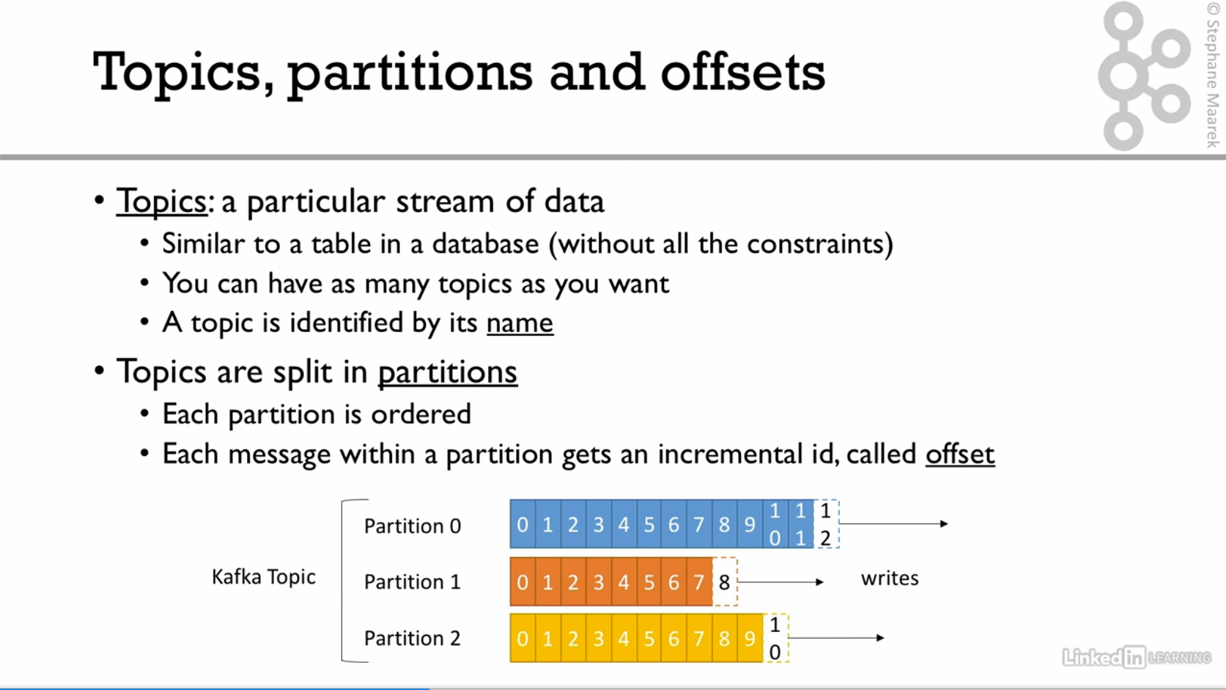

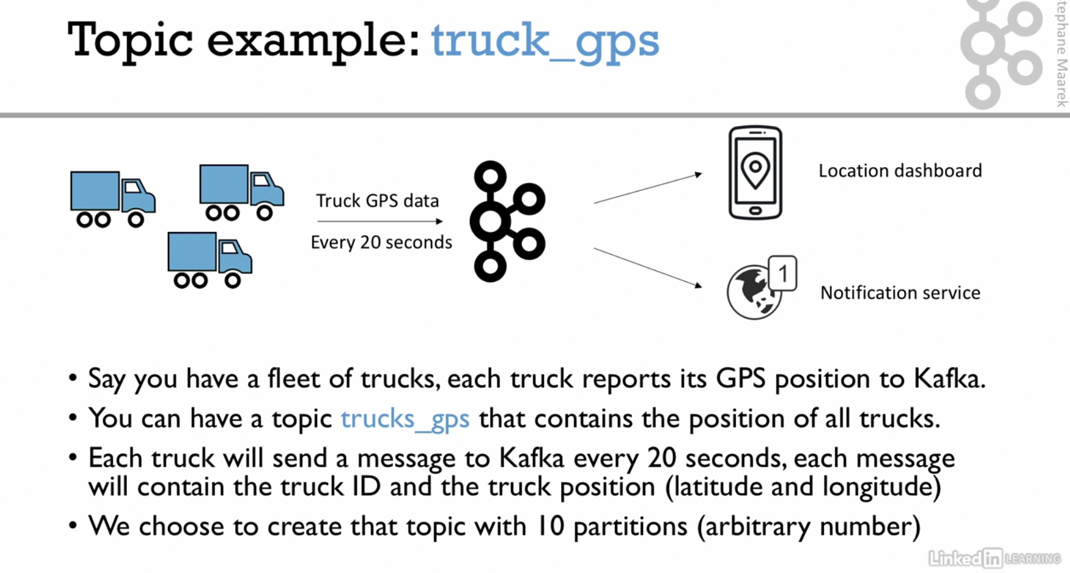

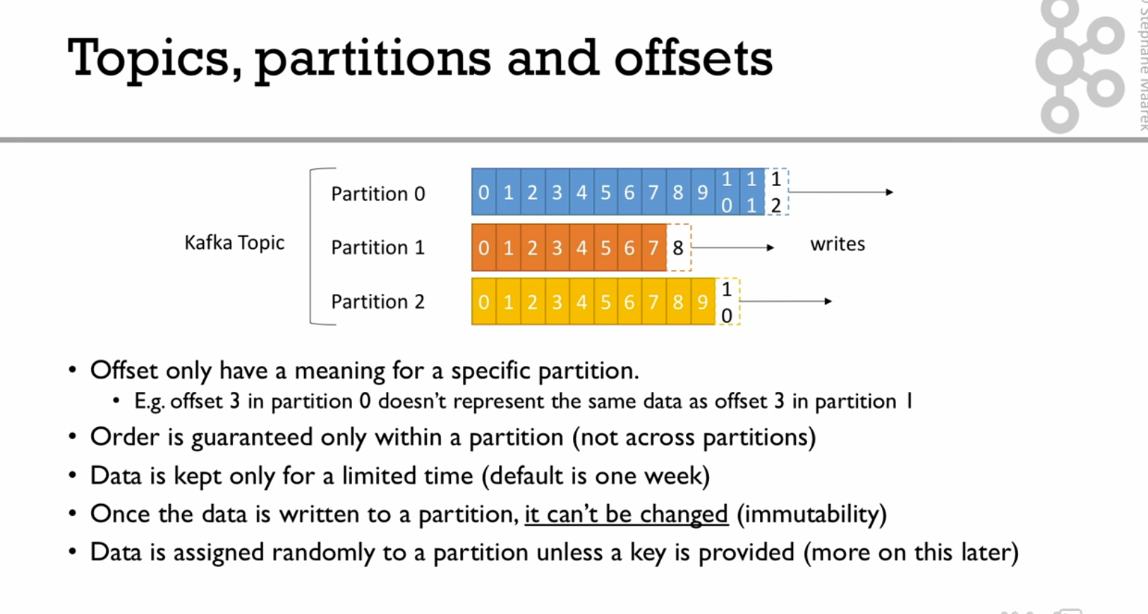

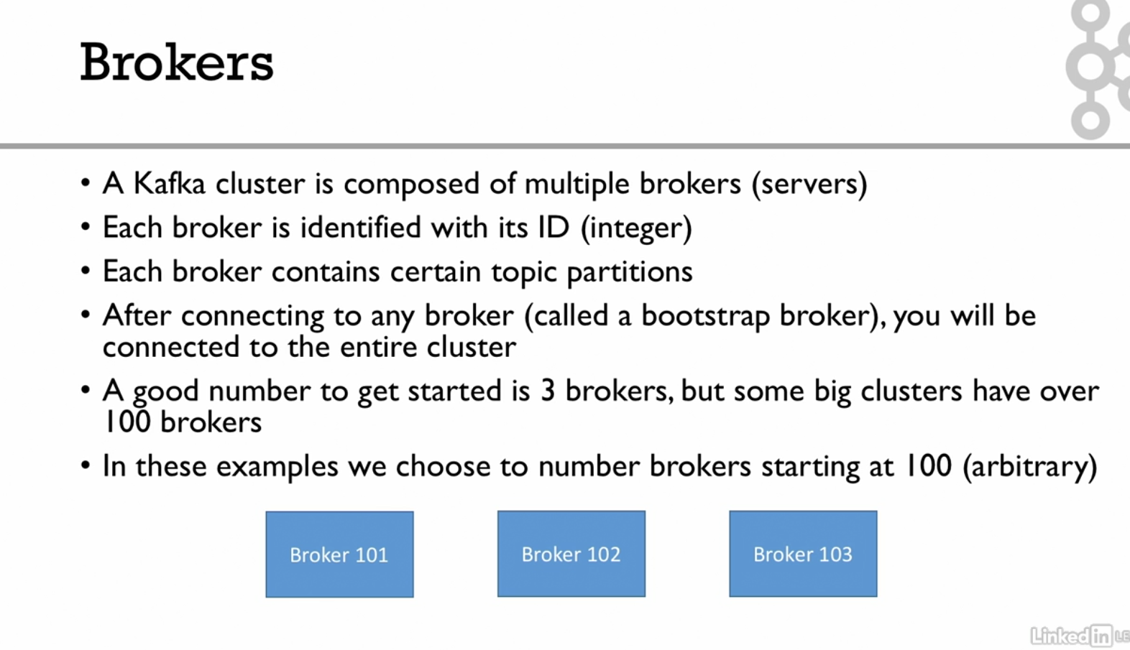

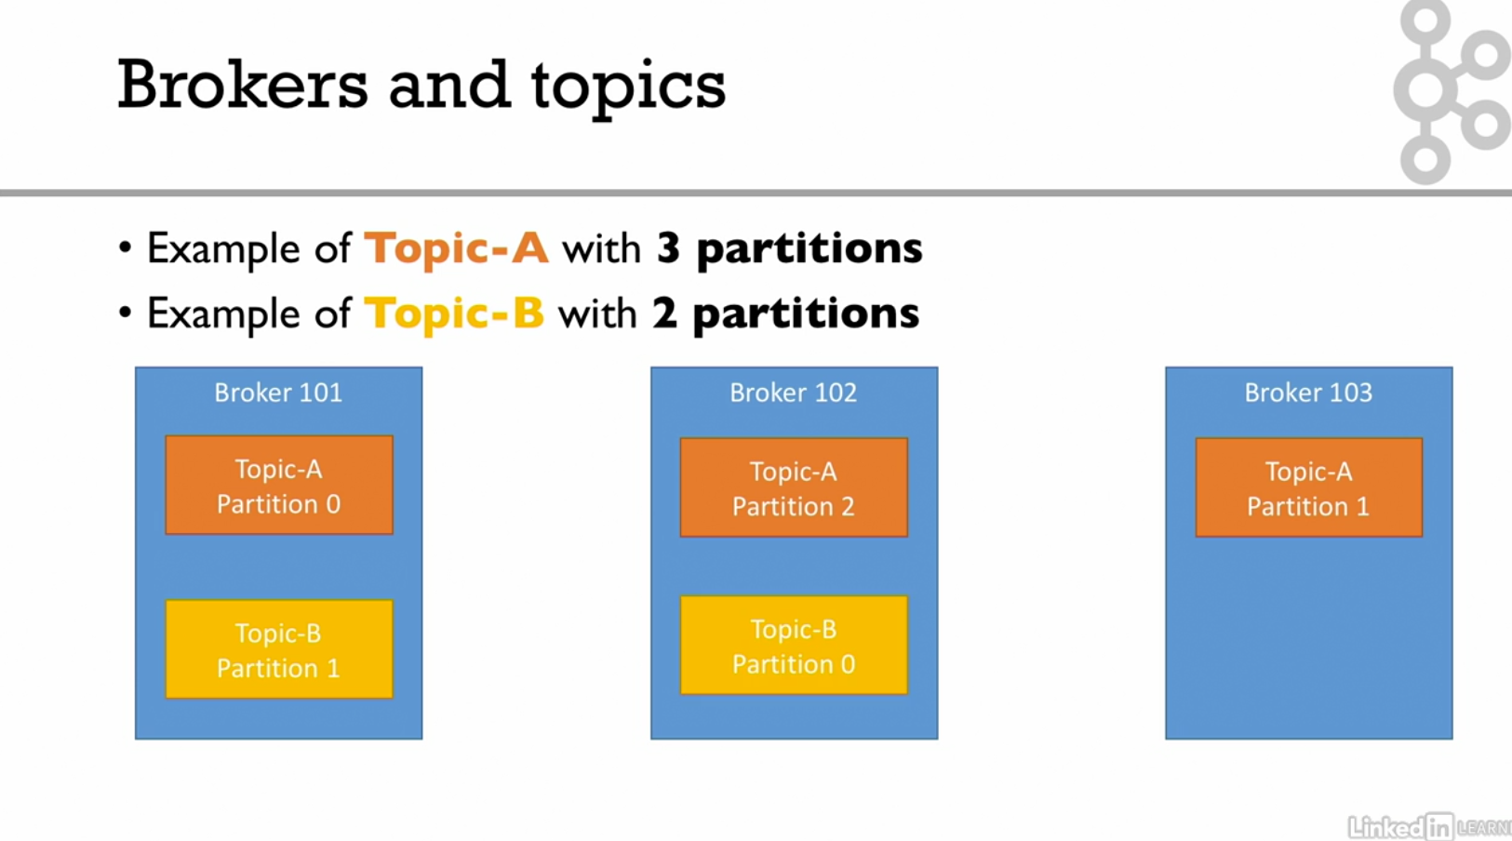

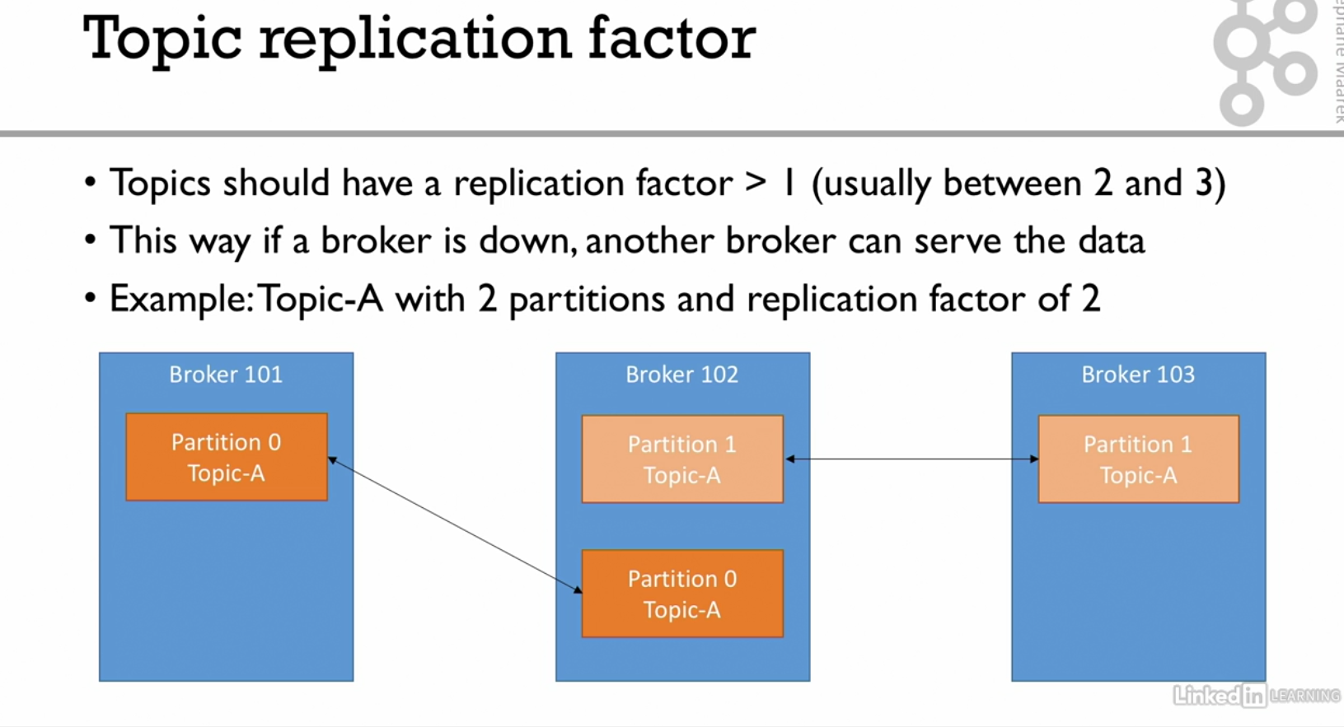

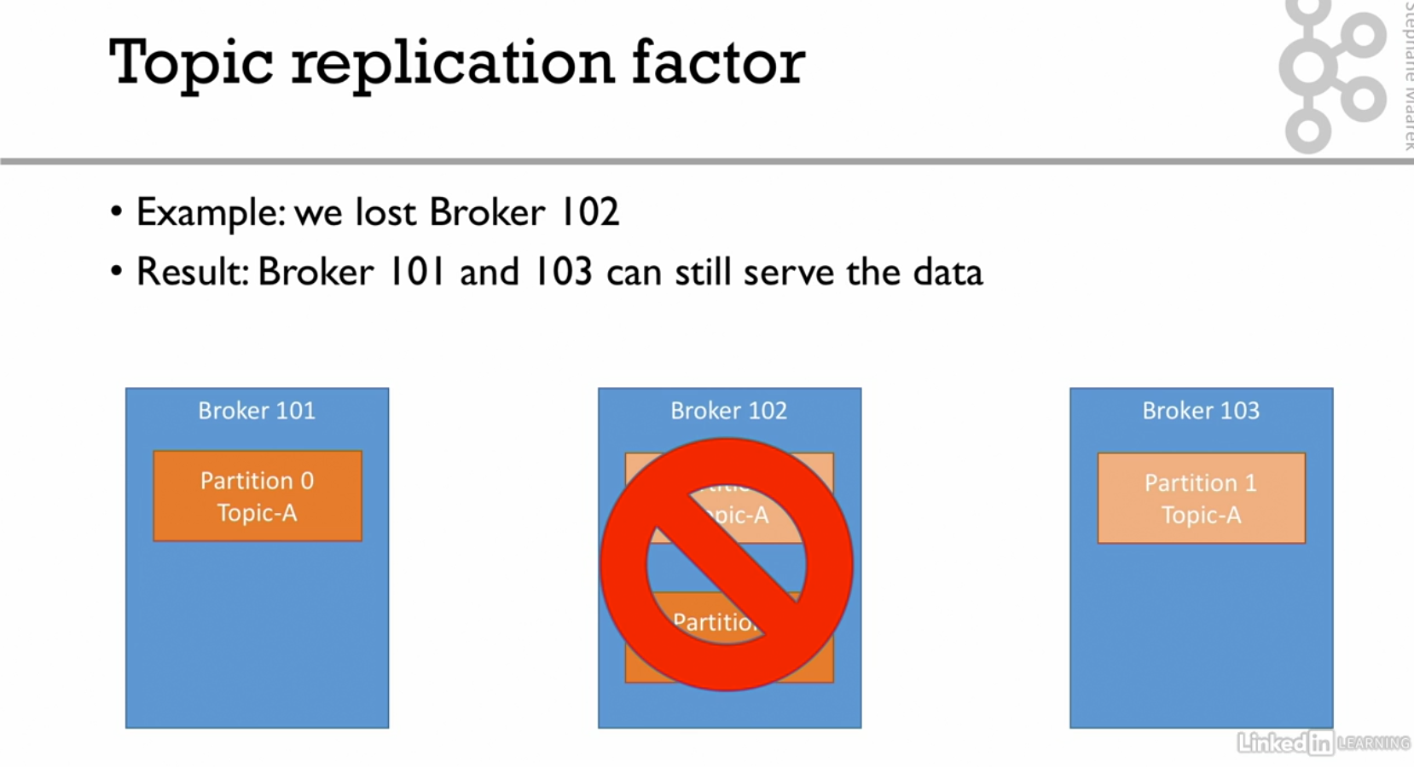

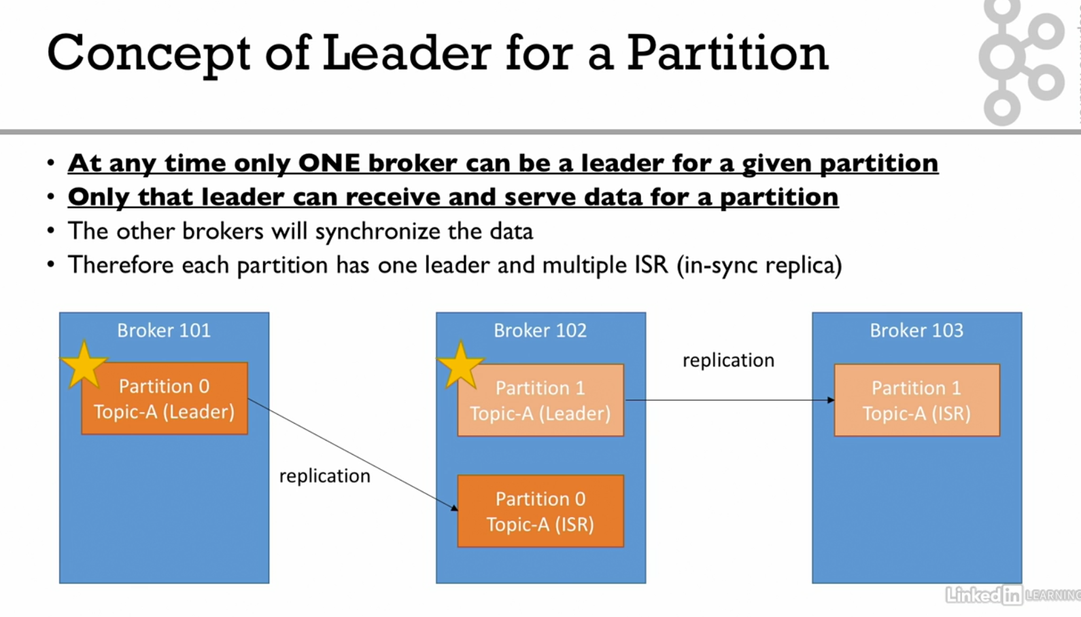

Leader and ISR are decided by zookeeper. If partition 0 of broker 101 down partition 0 of broker 102 will become leader and once partition 0 of broker 101 comes it will again become leader.

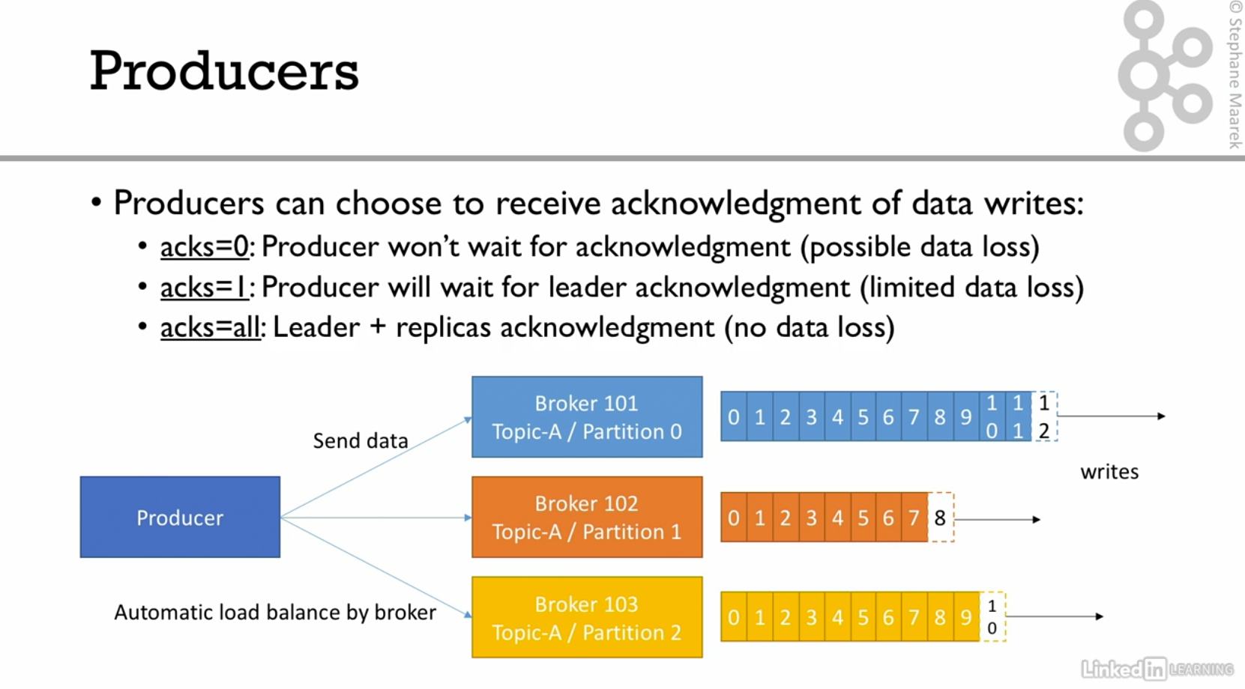

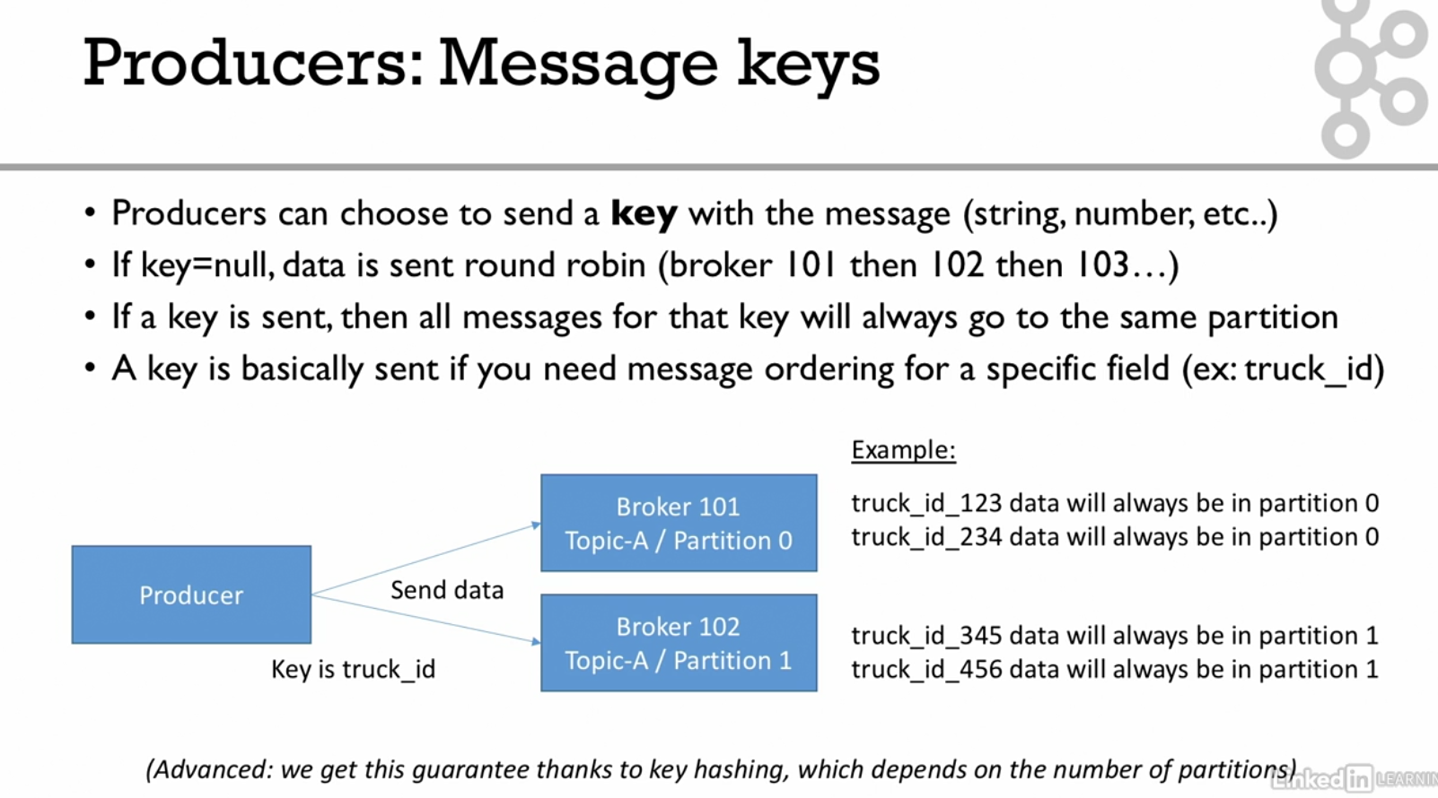

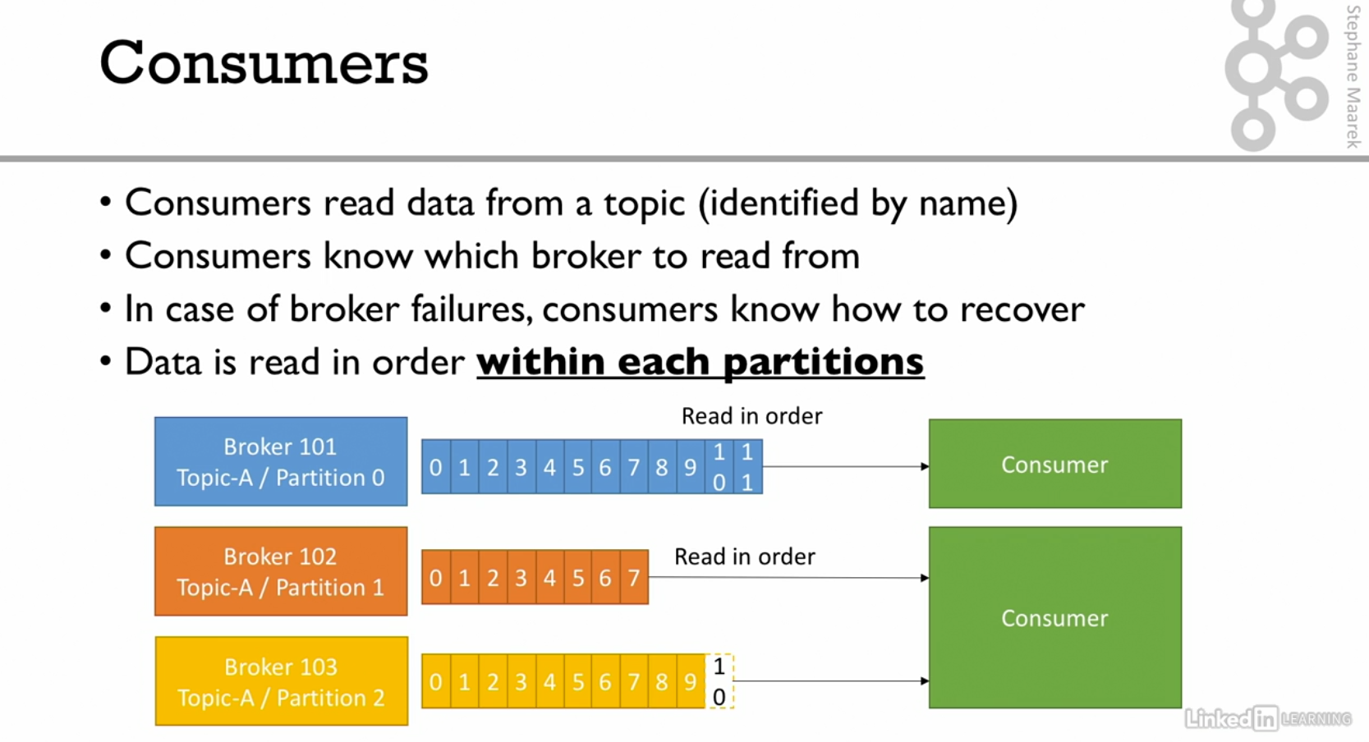

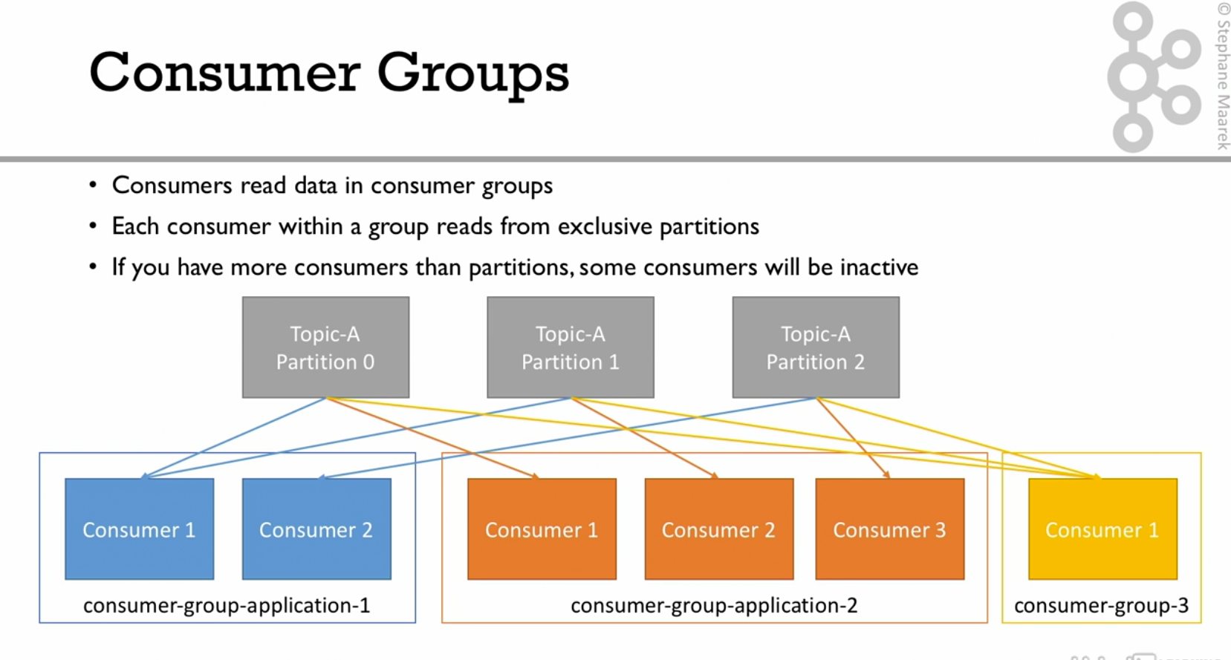

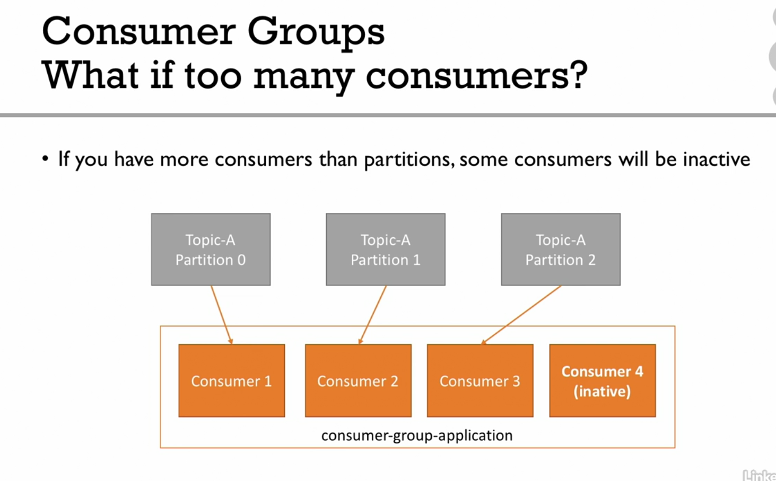

Number of consumers is usually equal to number of partitions

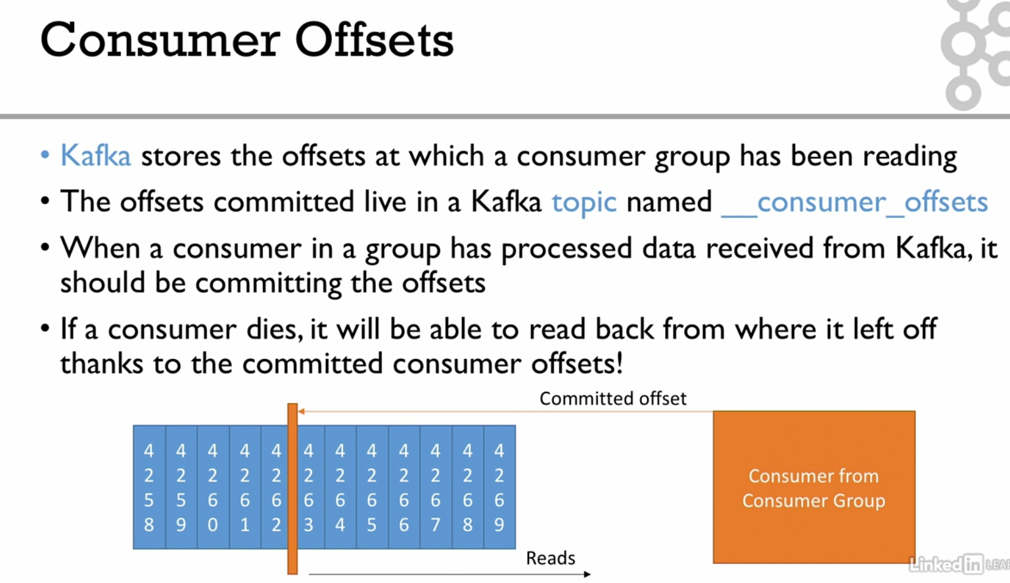

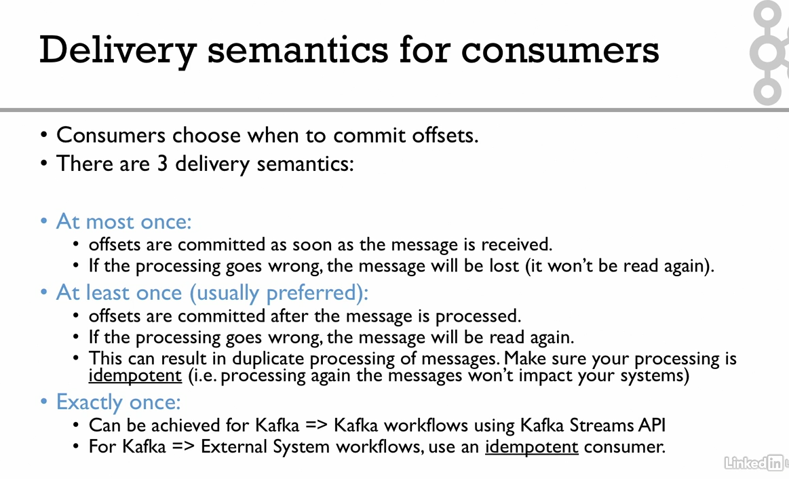

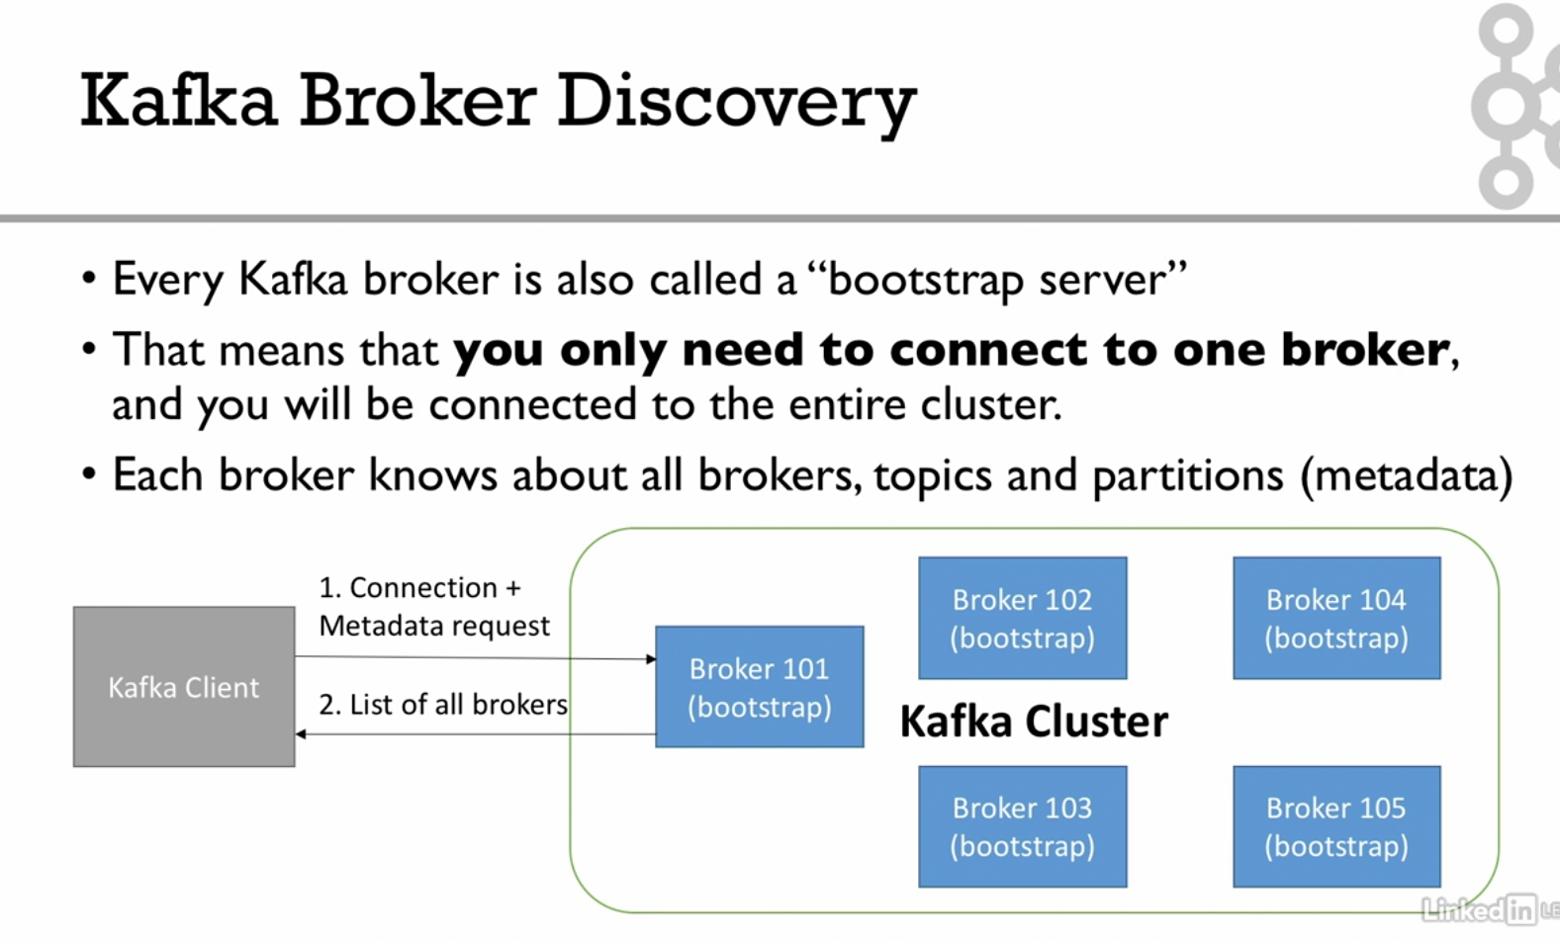

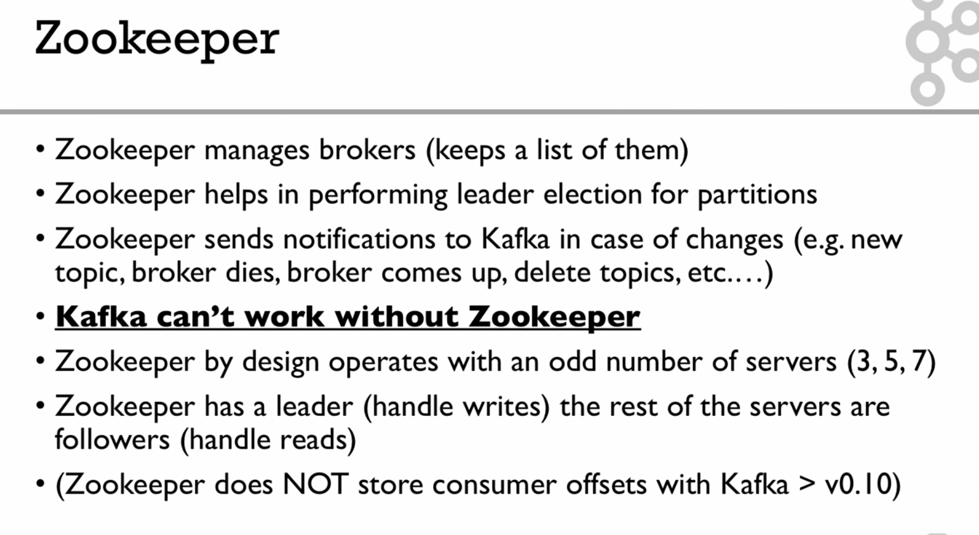

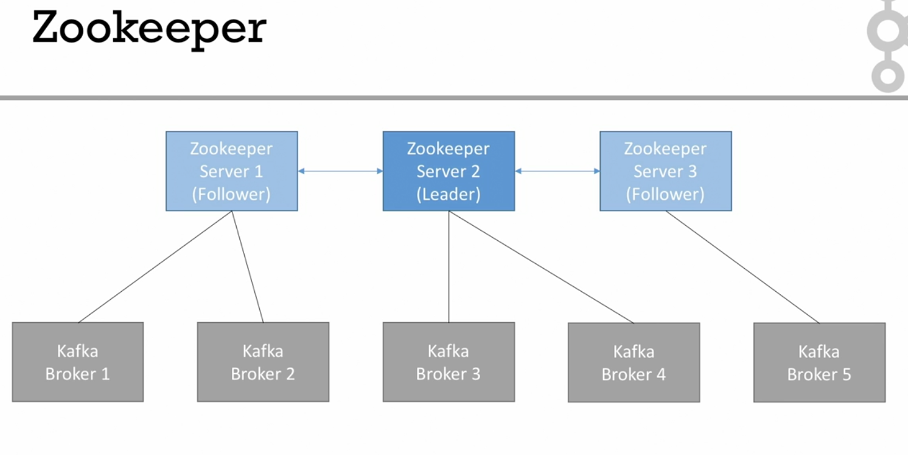

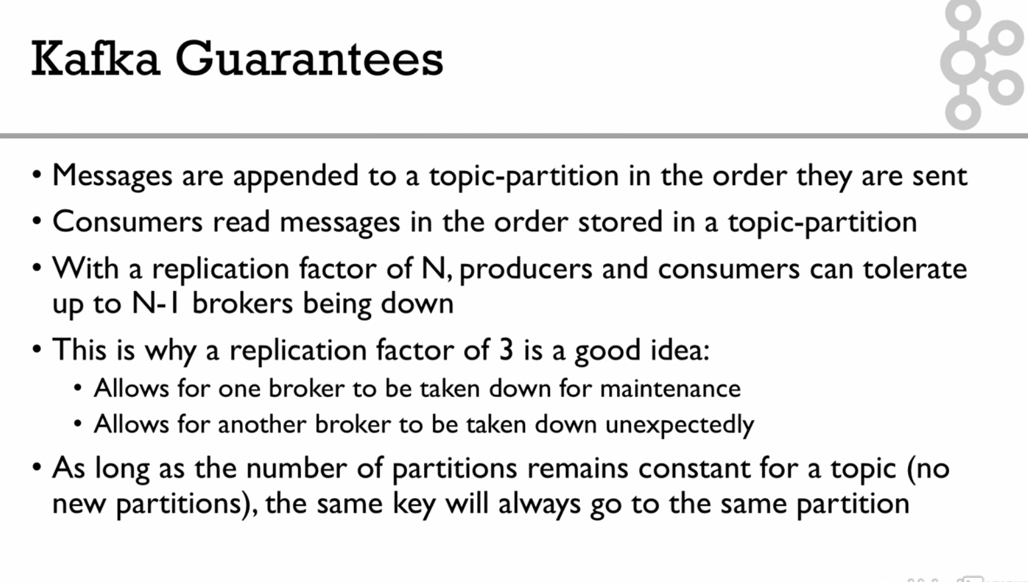

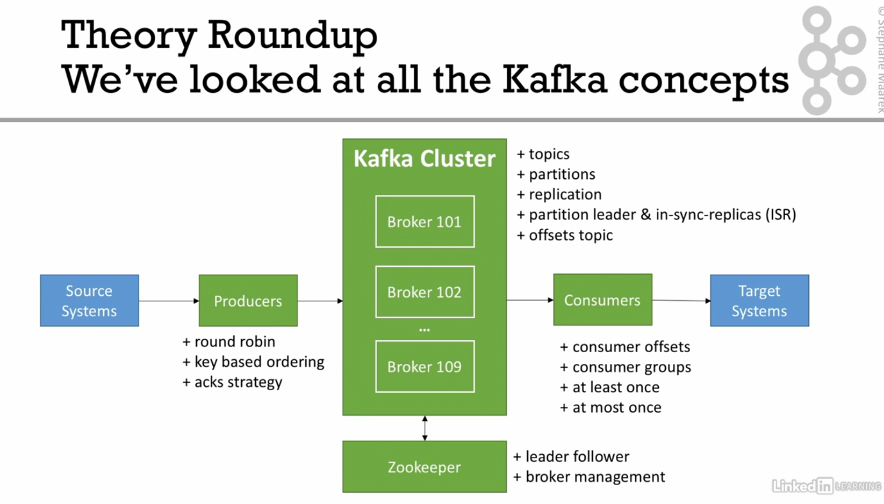

Installation:-

Step-1: Downlod jdk

Step 2: download kafka

Step 3: start zookeeper: (2181)

zookeeper-server-start.bat config\zookeeper.properties

step 4: start kafka (1 broker started at 9092)

kafka-server-start.bat config\server.properties

**Command line interface**

1. Kafka-topics : for all the documentation
2. kafka-topics --zookeeper 127.0.0.1:2181 --topic first_topic –create --partitions 3 --replication-factor 1

if we have just one broker we can’t have replication factor greater than 1

1. kafka-topics --zookeeper 127.0.0.1:2181 --list //to list all thr topics
2. kafka-topics --zookeeper 127.0.0.1:2181 --topic first_topic --describe //to describe about the topics

**kafka console producer cli**

1. kafka-console-producer --broker-list 127.0.0.1:9092 --topic first_topic //produce messages
2. kafka-console-producer --broker-list 127.0.0.1:9092 --topic first_topic --producer-property acks=all //acks=all

**Kafka console consumer CLI**

kafka-console-consumer --bootstrap-server 127.0.0.1:9092 --topic first_topic

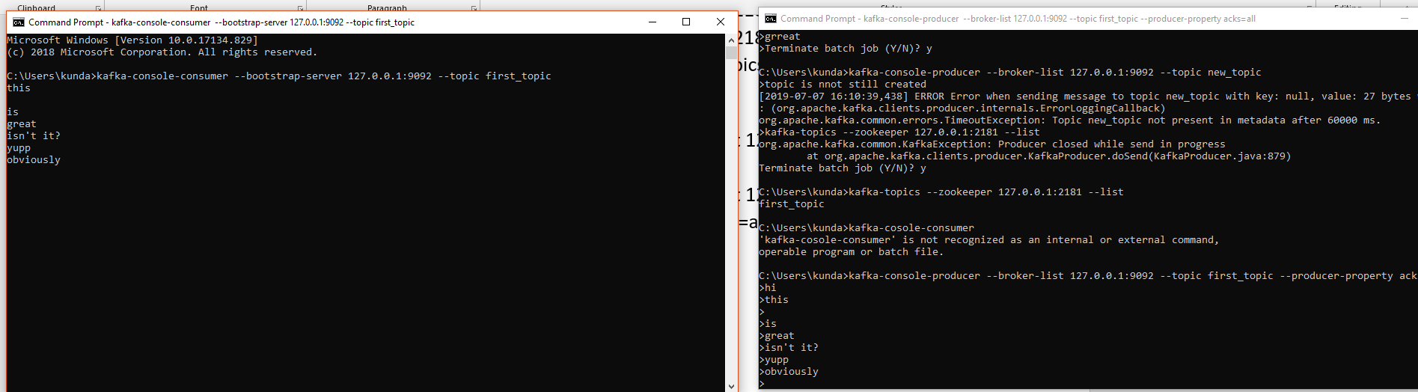

Once both terminal are open then only you can read the messages else can’t.

**Kafka Consumers in group**

kafka-console-consumer --bootstrap-server 127.0.0.1:9092 --topic first_topic --group my-first-application

each consumer reading from different partitions using round robin manner.

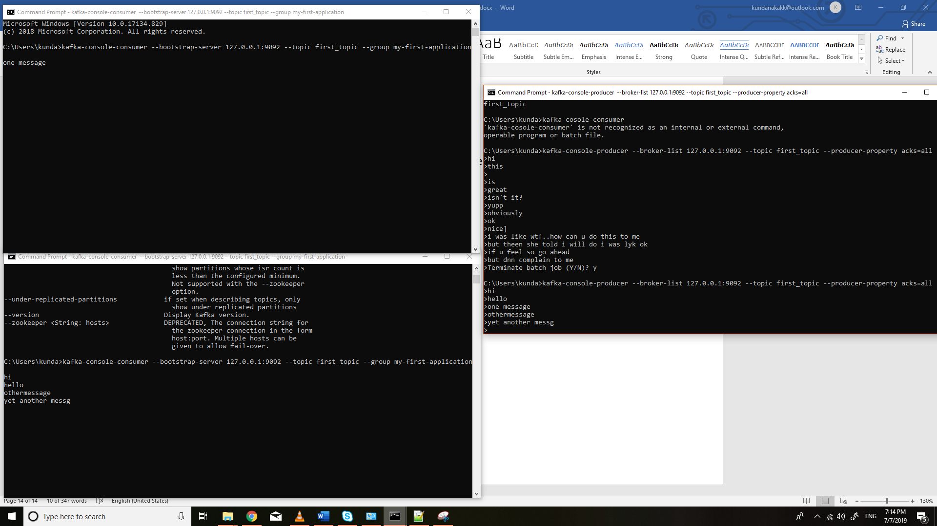

Below is three consumer group from one producer with three partitions. They all are getting messages in the round robin manner.

Each consumer Is getting mapped to one of the partitions.

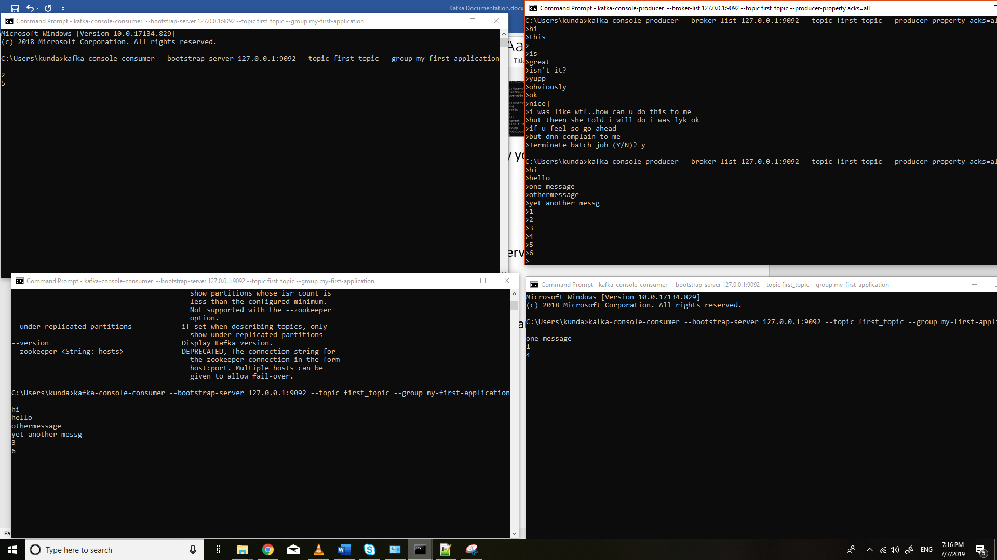

If we have more than consumers than number of partitions than one of the consumer becomes idle.(as in pic 2nd top is not getting any data)

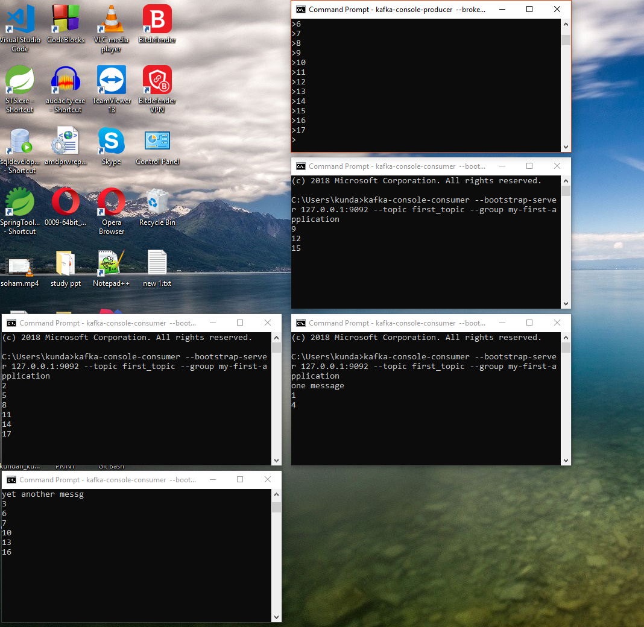

e.g 2. If we make a different consumer group reading the same partition from the beginning. What happens?

kafka-console-consumer --bootstrap-server 127.0.0.1:9092 --topic first_topic --group my-second-application --from-beginning

it gets all the messages produced by the producer so far

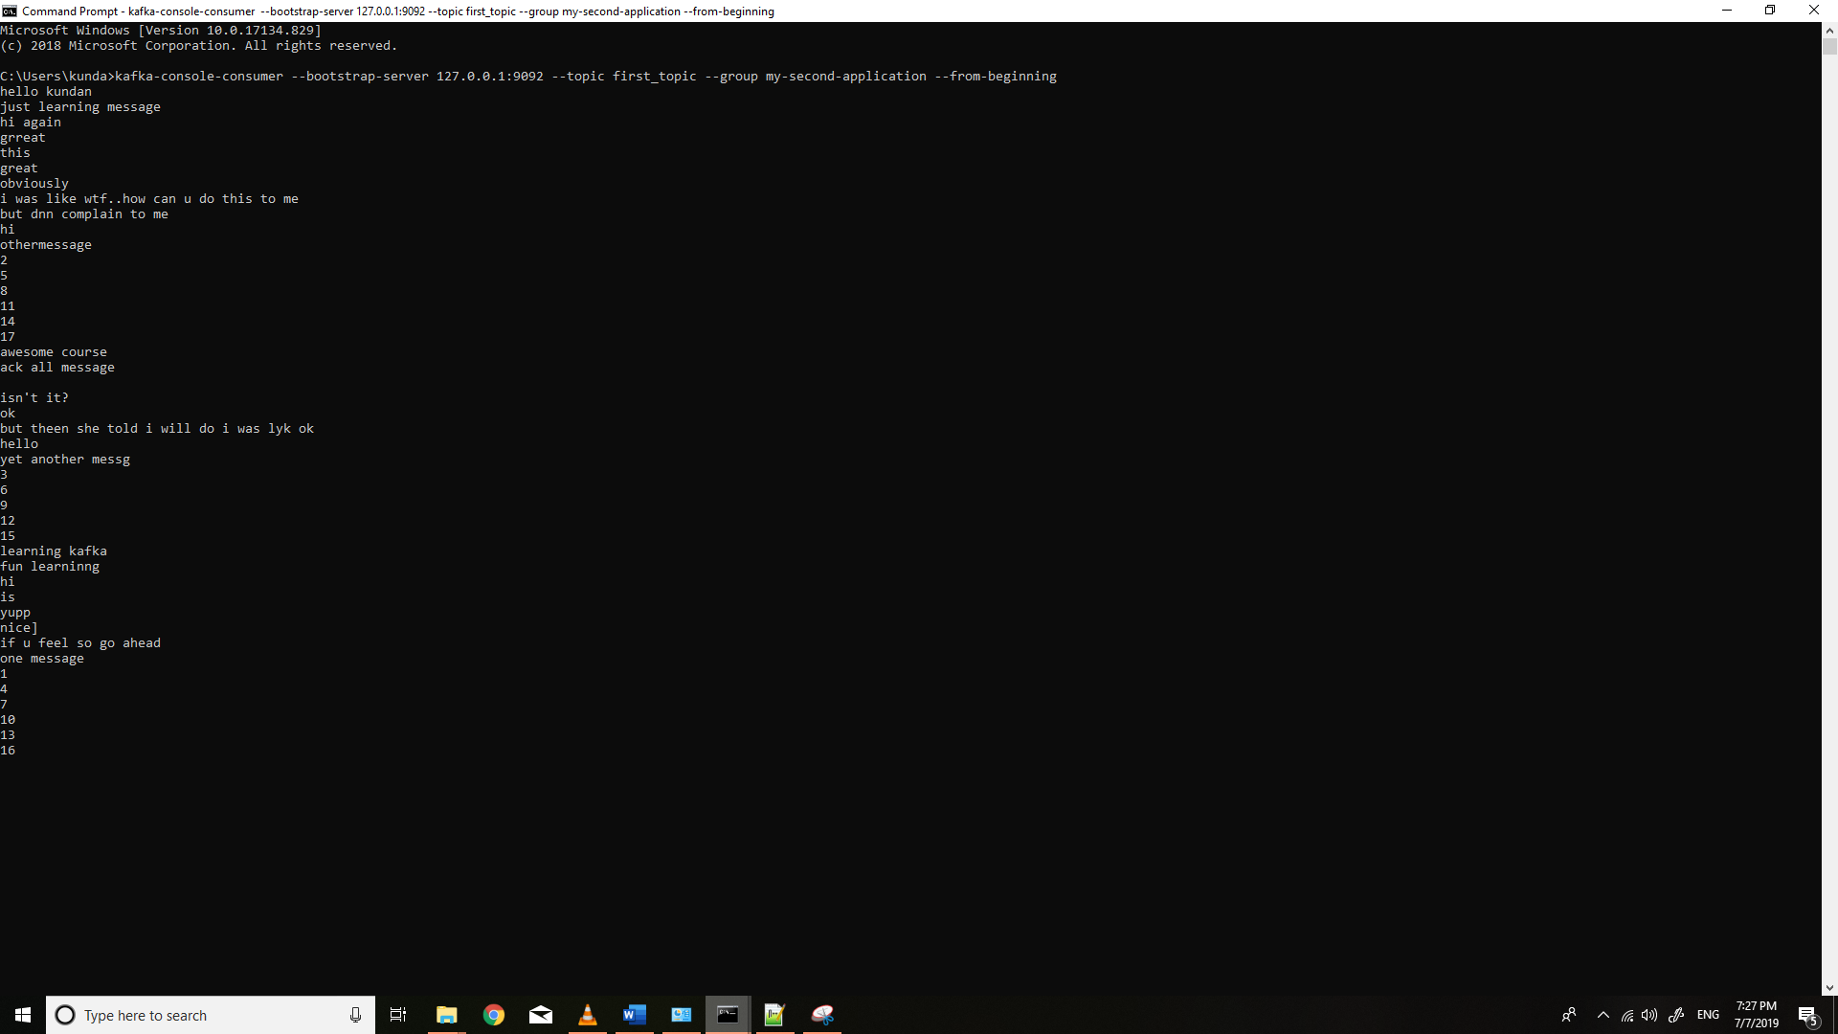

But if you stop this group and again start from the beginning you won’t get all the messages as offset is set which tells group 2 has read all the messages

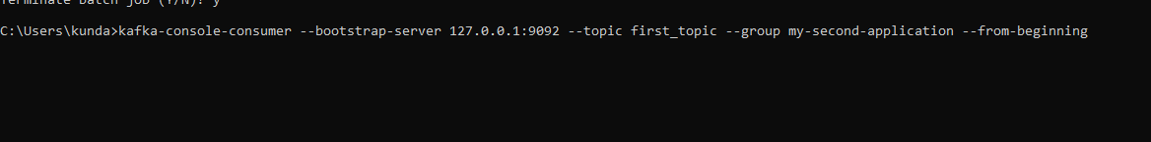

And if we have two consumer groups..data will go to each of them and internally in round robin manner if a group has many instances.

e.g produces new message came in both of the consumer

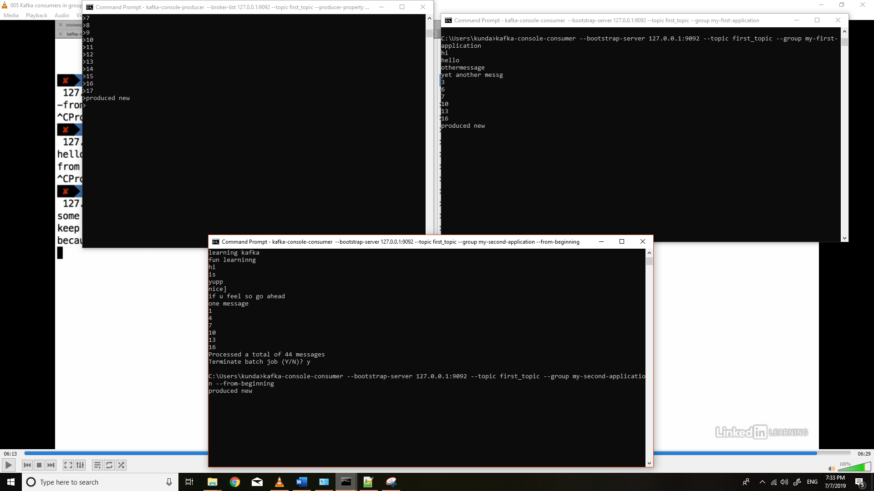

**Resetting offsets:-**

Offsets can be reset so that consumer can start reading from sm previous date/time etc

Kafka-consumer-groups --bootstrap-server localhost:9092 --group my-first-application --reset-offsets --to-earliest --execute --topic first-topic

**Kafka Java Programming**